**COS20007 - Weekly Task Report**

|  |  |
| --- | --- |
| Name: | Jason Ang Chia Wuen |
| Student ID: | **100087252** |
| Tutorial group: | [Group 01 – Thursday (8.30am – 11:30am)] |
| Pass tasks | [Indicate the pass tasks attempted eg. Pass task 1 - 4 & completion date] |

**Related learning outcomes**

|  |
| --- |
| **ULO1: OO Principles** |
| Explain how you have achieved unit learning outcome 1 for the tasks attempted for the week.  For example:  Pass task 2: I’ve learned object encapsulation, which hides the internal state of the program. I learned how to access to the encapsulated methods through accessors and mutators.  Refer to Figure 1 for snippets of codes produced in this task.  Pass task 3: ….. |

|  |
| --- |
| **ULO2: OO Language and libraries** |
| Pass task 3: I’ve learned how to create class and constructor (as shown in Figure 2), C# syntaxes such as the use of conditional “if” statements. |

|  |
| --- |
| **ULO3: Design, Develop and Test** |
|  |

|  |
| --- |
| **ULO4: Communicate using UML Diagrams** |
|  |

|  |
| --- |
| **ULO5: Describe Elements of Good OO Design** |
|  |

**Screenshots**

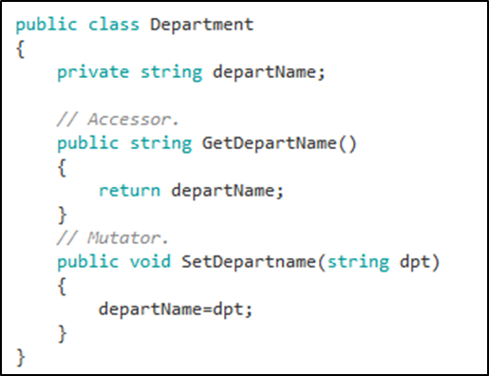

Figure 1 : accessor and mutator

[elaborations…..]

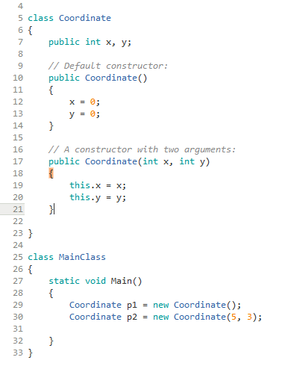

Figure 2: class constructors

[elaborations…..]